Adjective Phrase Attribute

✅ What is Adjective Phrase Attribute?
# Source: AI Source: Provided by: [Data Path: Persons Table -> ID Column: 1, Name_En Column: Motasem Essam] -> From: [Chatgpt (GPT‑5 Mini)] on [8/7/2025]
An Adjective Phrase Attribute is an adjective along with its modifiers that functions as an attribute within a noun phrase, describing or qualifying a noun. Unlike a single-word adjective, an adjective phrase gives more detailed information.

🔹 Key Features:
# Source: AI Source: Provided by: [Data Path: Persons Table -> ID Column: 1, Name_En Column: Motasem Essam] -> From: [Chatgpt (GPT‑5 Mini)] on [8/7/2025]
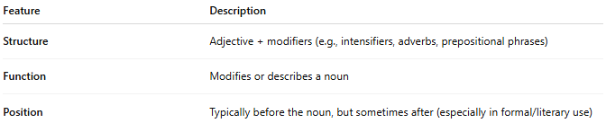
Feature | Description
Structure | Adjective + modifiers (e.g., intensifiers, adverbs, prepositional phrases)
Function | Modifies or describes a noun
Position | Typically before the noun, but sometimes after (especially in formal/literary use)

🔹 Examples:
# Source: AI Source: Provided by: [Data Path: Persons Table -> ID Column: 1, Name_En Column: Motasem Essam] -> From: [Chatgpt (GPT‑5 Mini)] on [8/7/2025]
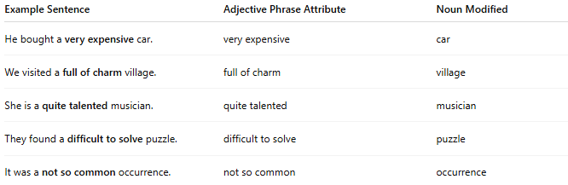
Example Sentence | Adjective Phrase Attribute | Noun Modified
He bought a very expensive car. | very expensive | car
We visited a full of charm village. | full of charm | village
She is a quite talented musician. | quite talented | musician
They found a difficult to solve puzzle. | difficult to solve | puzzle
It was a not so common occurrence. | not so common | occurrence

🔹 Common Components of Adjective Phrases:
# Source: AI Source: Provided by: [Data Path: Persons Table -> ID Column: 1, Name_En Column: Motasem Essam] -> From: [Chatgpt (GPT‑5 Mini)] on [8/7/2025]
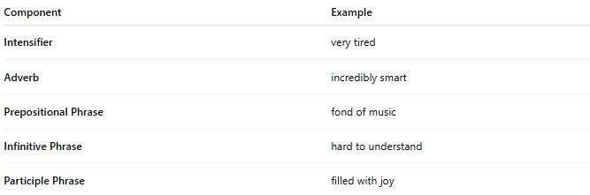
Component | Example
Intensifier | very tired
Adverb | incredibly smart
Prepositional Phrase | fond of music
Infinitive Phrase | hard to understand
Participle Phrase | filled with joy

